Icp assignement 2

Name:arun kumar silapuram

700763587

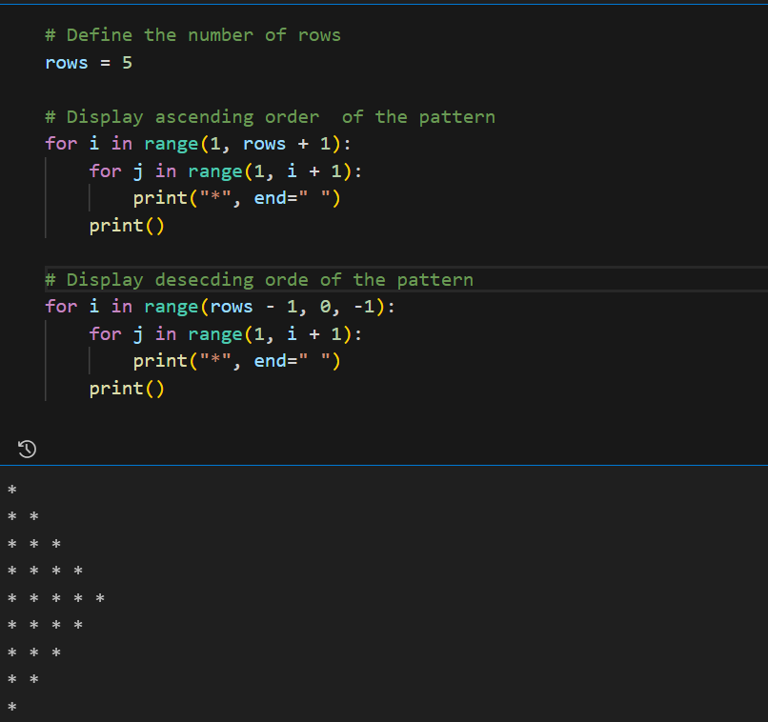

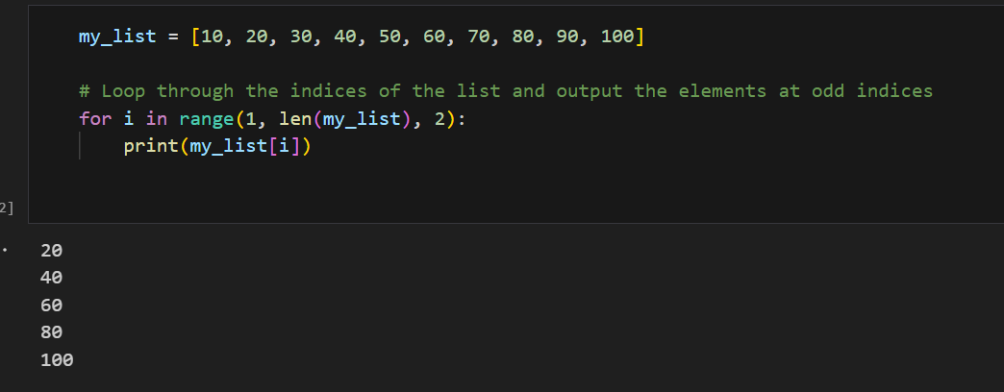

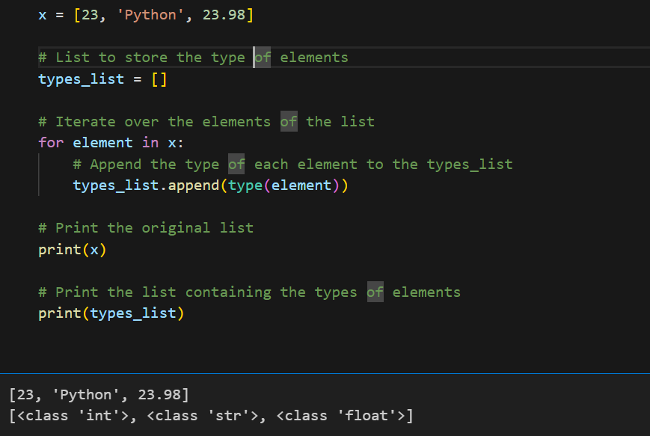

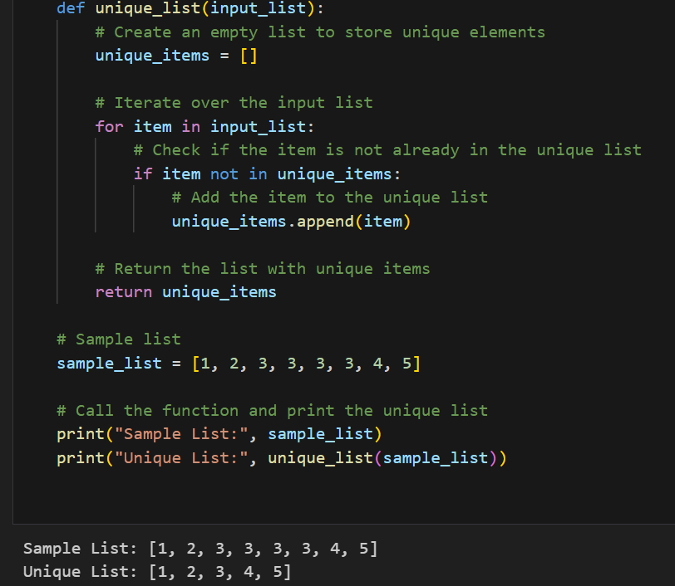

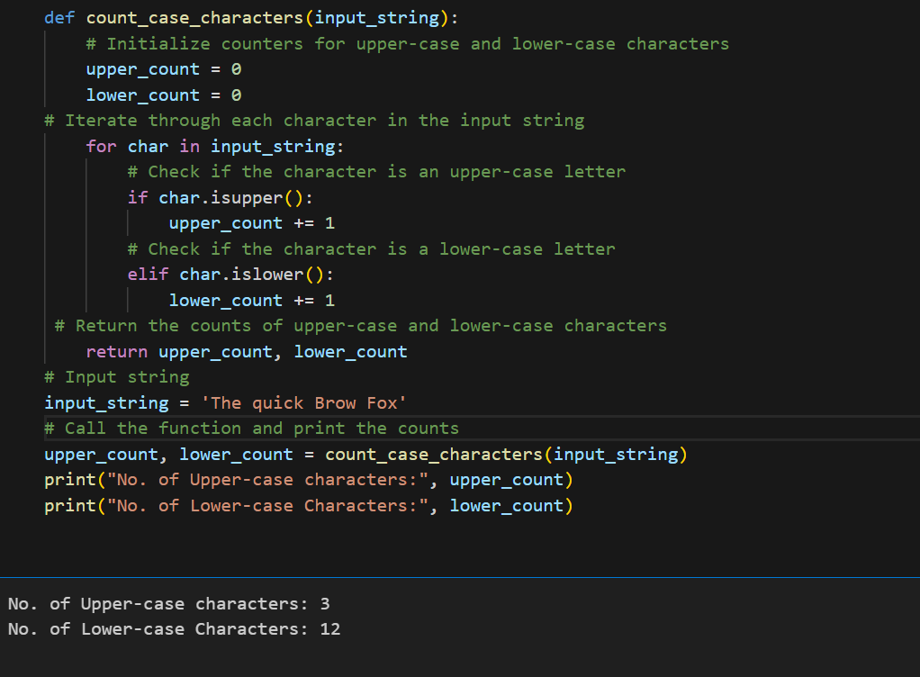

Video link: <https://vimeo.com/953738787/05a6aa8c3a>

Git hub: <https://github.com/Arunkumarsilapuram/assignment-2>